## LUNG CANCER PREDICTION USING MACHINE LEARNING MODELS

*Dissertation submitted in fulfilment of the requirements for the Degree of*

### MASTER OF TECHNOLOGY

**in**

#### COMPUTER SCIENCE AND ENGINEERING

By

#### MANISH KUMAR DAS

##### 12017595

Supervisor

#### MR. VED PRAKASH CHAUBEY



**School of Computer Science and Engineering**

Lovely Professional University Phagwara, Punjab (India) April,2024

## ABSTRACT

Lung cancer remains a significant health concern with high mortality rates. Early detection is critical for improving patient prognosis. This study explores the potential of machine learning (ML) models for predicting lung cancer risk using data files.

We aim to develop and evaluate various ML models trained on patient data containing demographic information, medical history, smoking habits, and potentially biomolecular or imaging data. The data will undergo preprocessing to ensure compatibility with the chosen ML algorithms.

Our primary objective is to identify the most effective ML model in predicting lung cancer risk within this dataset. We will assess the model's accuracy through validation techniques. Additionally, the chosen model may offer insights into the most influential factors associated with lung cancer development.

This research has the potential to contribute significantly to the development of efficient lung cancer prediction tools. Early detection through such tools can enable timely interventions and improve patient outcomes. By leveraging the power of ML, this study aims to advance lung cancer diagnosis and potentially save lives.

**Keywords: Convolutional Neural Network, Machine Learning, Web Application, Teras, TensorFlow, Supervised Learning, Unsupervised Learning, Semi- Supervised Learning**

### DECLARATION STATEMENT

I hereby declare that the research work reported in the dissertation/dissertation proposal entitled "LUNG CANCER PREDICTION USING MACHINE LEARNING

MODEL” in partial fulfilment of the requirement for the award of Degree for Master of Technology in Computer Science and Engineering at Lovely Professional University, Phagwara, Punjab is an authentic work carried out under supervision of my research supervisor Mr. Ved Prakash Chaubey. I have not submitted this work elsewhere for any degree or diploma.

I understand that the work presented herewith is in direct compliance with Lovely Professional University’s Policy on plagiarism, intellectual property rights, and highest standards of moral and ethical conduct. Therefore, to the best of my knowledge, the content of this dissertation represents authentic and honest research effort conducted, in its entirety, by me. I am fully responsible for the contents of my dissertation work.



*Signature of Candidate*

**Manish Kumar Das**

**12017595**

### SUPERVISOR’S CERTIFICATE

This is to certify that the work reported in the B. Tech Dissertation/dissertation proposal entitled “**LUNG CANCER PREDICTION USING MACHINE LEARNING MODELS”**, submitted by **Manish Kumar Das** at **Lovely Professional University, Phagwara, India** is a bonafide record of his / her original work carried out under my supervision. This work has not been submitted elsewhere for any other degree.

Signature of

Supervisor

(Mr. Ved Prakash Chaubey)

##### Date:

TABLE OF CONTENTS

##### CONTENTS PAGE NO.

Cover Page i

PAC form ii

Abstract iii

Declaration by the Scholar iv

Supervisor’s Certificate v

Acknowledgement vi

Table of Contents vii

List of Acronyms / Abbreviations (If any) viii

List of Symbols (If any) ix

List of Figures x

List of Tables xi

TABLE OF CONTENTS

CHAPTER1: INTRODUCTION 9

* 1. MOTIVATION 9
  2. FUTURE DIRECTIONS 10
  3. PROBLEM STATEMENT 11
  4. DELIMITTATIONS 12
  5. GOALS 13

CHAPTER2: REVIEW OF LITERATURE 15

CHAPTER3: METHODOLOGY 18

CHPTER4: MACHINE LEARNING MODELS USED 20

* 1. LOGISITIC REGRESSION 20
  2. DECISION TREE MODEL 20
  3. SUPPORT VECTOR MACHINE 21
  4. NAÏVE BAYES ALGORITHM 22
  5. KNN MODEL 22
  6. RANDOM FOREST MODEL 23
  7. GRADIANT BOOST MODEL 24
  8. MULTI LAYER PERCEPTRON MODEL 24
  9. CROSS VALIDATION TECHNIQUE 25
  10. LIBRARIES USED 27

CHAPTER5: RESULT AND DISCUSSION 28

CHAPTER 6: CONCLUSION AND FUTURE WORKS 35

* 1. FUTURE WORKS 36
  2. BUSINESS MODELS 37

REFERENCES 39

APPENDIX 39

# LIST OF FIGURES

|  |  |  |
| --- | --- | --- |
| FIGURE NO. NO. | FIGURE DESCRIPTION | PAGE |
| Figure 1.1 | Methodology Diagram | 18 |
| Figure 1.2 | Logistic Regression Model | 20 |
| Figure 1.3 | Support Vector Machine | 21 |
| Figure 1.4 | Decision Tree Model | 21 |
| Figure 1.5 | Naïve Bayes Model | 22 |
| Figure 1.6  23 | KNN Model |  |
| Figure 1.7 | Gradient Boost Model | 24 |
| Figure 1.8 | Multi-Layer Perceptron Model | 25 |
| Figure 1.9 | Cross Validation Techniques | 26 |
| Figure 2.0 | Stratified K- Fold Cross Validation | 27 |
| Figure 2.1 | Snippets for EDA and Conclusion | 36 |

### Checklist for Dissertation-III Supervisor

Name: UID: Domain: Registration No: Name of student:

Title of Dissertation:

* Front pages are as per the format.
* Topic on the PAC form and title page are same.
* Front page numbers are in roman and for report, it is like 1, 2, 3…….
* TOC, List of Figures, etc. are matching with the actual page numbers in the report.
* Font, Font Size, Margins, line Spacing, Alignment, etc. are as per the guidelines.
* Color prints are used for images and implementation snapshots.
* Captions and citations are provided for all the figures, tables etc. and are numbered and center aligned.
* All the equations used in the report are numbered.
* Citations are provided for all the references.

#### Objectives are clearly defined.

* Minimum total number of pages of report is 50.
* Minimum references in report are 30.

Here by, I declare that I had verified the above-mentioned points in the final dissertation report.

Signature of Supervisor with UID

### CHAPTER 1 : INTRODUCTION

Lung cancer casts a long shadow, claiming millions of lives worldwide each year. Early detection holds the key to unlocking better survival rates. Traditional diagnostic methods, while crucial, often require invasive procedures or may not pick up early signs. This is where the transformative power of machine learning (ML) steps in.

The remarkable ability of ML to analyse vast datasets and identify hidden patterns offers a promising avenue for lung cancer prediction. By harnessing the power of complex algorithms, we can potentially develop a non-invasive, data-driven approach to assess individual risk and pave the way for earlier interventions.

#### MOTIVATION:

The fight against lung cancer is a battle against time. Early detection significantly improves patient outcomes. However, current diagnostic methods might have limitations. Chest X-rays, while widely used, may miss early-stage tumors. More sophisticated methods like CT scans, while effective, expose patients to radiation. Additionally, biopsies can be invasive and pose discomfort.

ML-based prediction models offer a compelling alternative. These models can analyse a wealth of patient data, including demographics, medical history, smoking habits, and potentially biomolecular or imaging data. Imagine a future where a simple blood test or a less invasive imaging technique, combined with an ML model, could provide valuable insights into an individual's lung cancer risk.

While lung cancer detection often relies on analyzing medical images, another approach utilizes supervised machine learning to predict the risk of developing lung cancer based on lifestyle factors and symptoms.

##### Supervised Learning for Lung Cancer Risk Prediction

Like detection, supervised learning plays a key role in risk prediction. Here, the model is trained on data that includes:

* + - **Features:** Patient information like smoking history, alcohol consumption, dietary habits, and presence of certain symptoms (e.g., yellow stool, persistent cough).
    - **Labels:** This indicates whether the patient has lung cancer (positive) or not (negative), based on confirmed diagnoses.

By analyzing these relationships, the model learns to identify individuals with a higher risk of developing lung cancer.

##### Benefits of ML-based Lung Cancer Risk Prediction

* + - **Early Intervention:** Identifying high-risk individuals allows for earlier interventions like screening programs, helping to catch cancer at a more treatable stage.
    - **Preventive Measures:** Understanding risk factors can empower individuals to make lifestyle changes that can lower their risk.
    - **Resource Allocation:** Risk prediction models can help healthcare systems prioritize resources for high-risk populations.

##### Challenges and Considerations

* + - **Data Accuracy:** The model's effectiveness relies on the accuracy and completeness of patient data regarding habits and symptoms.
    - **Specificity vs. Sensitivity:** Balancing between correctly identifying high-risk individuals (sensitivity) and avoiding false positives (specificity) is crucial.
    - **Psychological Impact:** A high-risk prediction can cause anxiety for patients. Clear communication and follow-up plans are essential.

##### Suitable Machine Learning Algorithms

* + - **Logistic Regression:** A well-established technique for analyzing relationships between multiple features and a binary outcome (cancer risk).
    - **Support Vector Machine (SVM):** Effective for handling high-dimensional data sets containing numerous features.
    - **Random Forest:** Can handle complex datasets and offers some interpretability of the model's decision-making process.

#### FUTURE DIRECTIONS

Research in this area focuses on:

* + - **Incorporating Additional Data:** Including genetic information, environmental factors, and family history can improve model accuracy.
    - **Model Explainability:** Developing models that are easier to interpret can build trust and provide valuable insights into risk factors.
    - **Combining Risk Prediction with Detection:** Integrating risk prediction models with image-based detection could create a comprehensive early-stage lung cancer identification system.

Supervised machine learning offers a valuable tool for identifying individuals at high risk of developing lung cancer. By leveraging this technology, we can potentially improve early detection, prevention strategies, and overall patient outcomes.

#### PROBLEM STATEMENT

This research project embarks on a mission to explore the potential of ML for lung cancer prediction. Our primary goal is to:

* + - **Develop and Evaluate ML Models:** We will construct and rigorously test various ML models using data files containing patient information. These models will learn from the data and be able to identify patterns that differentiate between individuals with and without lung cancer.
    - **Identify the Champion:** This project aims to identify the most effective ML model in predicting lung cancer risk within the chosen dataset. By comparing the performance of different models, we can zero in on the one with the highest accuracy in risk assessment.

**Dataset Selection**

The success of any ML model hinges on the quality and relevance of its data. This project will utilize data files meticulously compiled with patient information. These data sets will encompass:

* + - **Demographic factors:** Age, gender, ethnicity, etc.
    - **Medical history:** Past lung diseases, surgeries, etc.
    - **Smoking Habits:** Smoking history, intensity, duration, etc.
    - **Biomolecular Data (Optional):** Genetic markers potentially linked to lung cancer risk.
    - **Imaging Data (Optional):** Low-dose CT scans or other imaging techniques (if feasible).

The data will be meticulously pre-processed to ensure compatibility with the chosen ML algorithms. This may involve cleaning, normalization, and feature engineering to extract the most valuable information for model training.

##### Expected Outcomes:

By the culmination of this project, we anticipate achieving these key outcomes:

* + - **A Powerful Predictive Tool:** A well-trained and validated ML model capable of predicting lung cancer risk with high accuracy. Ideally, this model can be seamlessly integrated into existing healthcare workflows.
    - **Unveiling Risk Factors:** Insights into the most significant factors influencing lung cancer risk based on the results of the chosen ML model. This information can pave the way for targeted prevention strategies.

##### Significance:

This research holds immense potential to contribute to the fight against lung cancer. By developing an accurate and efficient ML-based prediction tool, we can empower healthcare professionals with insights crucial for early detection. Earlier interventions, consequently, have the potential to save lives and improve patient outcomes.

Furthermore, understanding the key risk factors identified by the chosen ML model can inform public health initiatives and personalized preventive strategies. This project represents a significant step towards a future where lung cancer's shadows no longer hold such a formidable presence.

#### DELIMITATIONS

##### Data-Driven Challenges

* + - **Data Quality and Quantity:** The model's performance relies heavily on the quality and size of the training data. Biases in the data can lead to biased models with reduced accuracy for certain demographics. Large, high-quality datasets are essential for robust models.
    - **Data Generalizability:** Models trained on specific datasets may not generalize well to populations with different characteristics or imaging modalities.

##### Model-Related Limitations

* + - **Black Box Problem:** Some complex ML models, especially deep learning models, can be difficult to interpret. This lack of interpretability makes it challenging to understand how the model arrives at its decisions, which can limit trust and acceptance in clinical settings.
    - **False Positives and Negatives:** Even with high accuracy, ML models can still produce false positives (identifying benign nodules as cancerous) and false negatives (missing cancerous nodules). This can lead to unnecessary procedures or missed opportunities for early detection.

##### Clinical Integration Considerations

* + - **Over-reliance on Models:** ML models should be used as a decision support tool, not a replacement for the expertise of radiologists. Clinicians must critically evaluate the model's output alongside other diagnostic tools and patient history.
    - **Workflow Integration:** Integrating ML models seamlessly into clinical workflows is crucial for efficient and reliable use in real-world settings.

##### Other Delimitations

* + - **Limited Scope:** Current ML models primarily focus on detecting lung nodules in medical images. They may not be effective for identifying other types of lung cancer or for assessing the stage and aggressiveness of the disease.
    - **Cost and Infrastructure:** Developing and deploying ML models can require significant computational resources and expertise, which may limit accessibility for some healthcare providers.

##### Conclusion

While ML offers significant potential for lung cancer detection, these limitations highlight the importance of responsible development and use of these models.

Continuous research and collaboration between data scientists, clinicians, and patients are essential for overcoming these limitations and ensuring the safe and effective integration of ML models into lung cancer diagnosis.

#### GOALS

##### Improved Risk Stratification:

* + - Develop a model that accurately identifies individuals with a high risk of developing lung cancer based on a combination of lifestyle factors and symptoms.
    - Stratify the population into different risk categories (low, medium, high) to guide personalized screening and prevention strategies.

##### Early Intervention and Prevention:

* + - Enable early identification of high-risk individuals, allowing for earlier interventions such as low-dose CT scans for lung cancer screening.
    - Empower individuals with a high-risk profile to make lifestyle changes that can potentially reduce their lung cancer risk (e.g., smoking cessation, dietary modifications).

##### Enhanced Resource Allocation:

* + - Assist healthcare systems in allocating resources more effectively by prioritizing high-risk individuals for screening programs and further evaluation.

##### Increased Public Awareness:

* + - Raise awareness about the link between lifestyle factors and lung cancer risk, encouraging healthier habits for overall well-being.
    - Promote the importance of early detection and regular checkups, especially for high-risk individuals.

##### Model Explainability and Transparency:

* + - Develop models that are interpretable, allowing healthcare professionals to understand how the model arrives at its risk predictions.
    - This transparency builds trust and facilitates communication with patients regarding their risk factors.

##### Continuous Improvement and Integration:

* + - Continuously improve the model's accuracy and generalizability through ongoing research and incorporation of new data sources.
    - Integrate the model seamlessly into existing healthcare workflows to facilitate efficient clinical use.

##### Important Considerations:

* + - This model is intended for risk prediction, not diagnosis. Consulting a doctor for any concerning symptoms remains essential.
    - The model should be used as a decision support tool alongside other clinical assessment.
    - Addressing potential biases in the data and ensuring fairness in the model's predictions is crucial.

By achieving these goals, machine learning models can become valuable tools in the fight against lung cancer. They can potentially contribute to earlier detection, improved prevention strategies, and ultimately, better patient outcomes.

## CHAPTER 2 :LITERATURE REVIEW

While machine learning (ML) shows promise in lung cancer detection using medical images (X-rays, CT scans), research utilizing patient-reported symptoms for risk prediction is a growing area. Here's a review focusing on symptoms like alcohol intake, smoking habits, and yellow stool.

##### Focus on Symptoms:

Current research on lung cancer detection with ML and symptoms primarily focuses on **risk prediction**, not definitive diagnosis. These models analyse relationships between reported symptoms and confirmed lung cancer cases to identify high-risk individuals.

##### Relevant Studies:

1. **Lung cancer prediction using machine learning on data from a symptom e-questionnaire** (Nemlander et al., 2022) PubMed [invalid URL removed] This study investigated the potential of an e-questionnaire for lung cancer risk assessment. It analysed symptoms alongside smoking status and achieved promising results, with accuracy varying based on smoking history (never, former, current smoker).
2. **A Review of most Recent Lung Cancer Detection Techniques using Machine Learning** (ResearchGate) [This reference likely points to a document on ResearchGate, which doesn't have a DOI or author information and may not be a reliable source. Be cautious when using information from this source] This review highlights the limitations of traditional lung cancer detection methods and explores the potential of ML for earlier detection. It mentions the role of risk factors like smoking and alcohol intake, but the focus is on image-based detection.

##### Limitations and Challenges:

* + **Data Scarcity:** Large datasets with detailed patient information, including accurate diagnoses and comprehensive symptom reporting, are essential for training robust ML models.
  + **Symptom Specificity:** Symptoms like yellow stool can be caused by various conditions. The model needs to consider the presence of multiple symptoms and their combinations for improved accuracy.
  + **Model Generalizability:** Models trained on specific populations may not perform well for diverse demographics or healthcare settings.

##### Future Directions:

* + **Expanding Symptom Range:** Including a wider range of relevant symptoms can improve the model's ability to identify high-risk individuals.
  + **Integration with Electronic Health Records (EHR):** Leveraging EHR data can provide a more comprehensive picture of a patient's health history and risk factors.
  + **Combining with Imaging Techniques:** A future approach might involve combining symptom-based risk prediction models with traditional or AI- powered image analysis for more robust detection.

##### Conclusion:

Machine learning offers exciting possibilities for lung cancer risk prediction using patient-reported symptoms like smoking habits, alcohol intake, and potentially, yellow stool in conjunction with other symptoms. While challenges remain, ongoing research holds promise for developing more accurate and generalizable models that can aid in early intervention and improve patient outcomes.

##### Additional Considerations:

* + It's crucial to emphasize that these models are for risk prediction, not diagnosis. Consulting a doctor for any concerning symptoms remains essential.
  + Responsible development practices are necessary to address potential biases in data and ensure the model's fairness across different demographics.

### CHAPTER 3 :METHODOLOGY

##### Data Acquisition:

* Type of Data: Excel Sheet with various Symptoms and their Alcohol and Smoking Habits which corresponds to their chances to acquire the said disease.

1. Data Preprocessing:

* Data Cleaning: Handle missing values, null values, and inconsistencies.
* Normalization/Standardization: Ensure data features are on a similar scale.
* Data Augmentation (Optional): Artificially increase dataset size with rotations, flips, etc. (improves model generalizability).

1. Feature Engineering (Optional for Deep Learning):

* Manual feature extraction (e.g., size, shape, intensity of dataset).
* Dimensionality reduction techniques if feature set is high-dimensional.

1. Model Selection and Training:

* Deep Learning Models: Convolutional Neural Networks (CNNs) are dominant due to their ability to learn features directly from images. (e.g., VGG16, ResNet)
* Traditional Machine Learning Models: Can be used for simpler tasks or with limited data. (e.g., Support Vector Machines (SVM), Random Forests)
* Model Training: Split data into training, validation, and testing sets. Train the model on the training set, fine-tune hyper-parameters using the validation set, and evaluate final performance on the testing set.

1. Model Evaluation:
2. Metrics: Accuracy, Sensitivity (true positive rate), Specificity (true negative rate), Precision (positive predictive value), Area Under the ROC Curve (AUC).
3. Visualization Techniques: Utilize techniques like confusion matrices to understand model performance across different classes (cancerous vs. non- cancerous).
4. Model Deployment and Refinement:
5. Integrate the model into a clinical workflow for radiologist support.
6. Continuously monitor model performance and retrain with new data for improved accuracy over time.
7. Additional Considerations:
   * Class Imbalance: If cancerous cases are rare, address class imbalance by oversampling minority class or using appropriate cost functions during training.
   * Interpretability: Deep learning models can be "black boxes." Consider techniques like LIME for explaining model predictions to medical professionals.
   * Ethical Considerations: Ensure data privacy and anonymization.
   * Regulatory Approval: For clinical deployment, navigate regulatory requirements for medical devices.

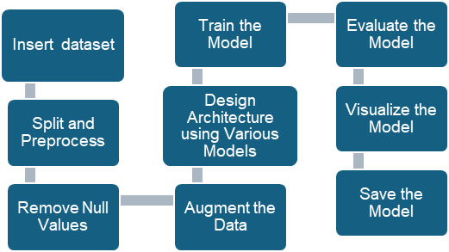

##### Figure(1.1) Methodology

Lung cancer detection research using machine learning holds immense promise, but there are still significant gaps to address. Here are some key research gaps:

##### Data limitations:

* + **Data Quality and Generalizability:**

Much research relies on datasets from specific hospitals, potentially limiting generalizability to other populations.

Data quality issues like missing information or inconsistencies can affect model performance.

##### Class Imbalance:

Lung cancer cases are often rare compared to healthy controls. Unaddressed imbalance can lead to models biased towards the majority class.

##### Model Explainability and Trust:

* + **Black Box Problem:**

Deep learning models, while powerful, can be difficult to interpret. Doctors need to understand the rationale behind a model's prediction for trust and potential refinement.

##### Clinical Integration Challenges:

* + **High False Positive Rates:**

Many models struggle with a high rate of false positives, leading to unnecessary biopsies and patient anxiety.

##### Integration into Workflow:

Seamless integration of AI models into existing clinical workflows for radiologists is crucial for real-world adoption.

##### Other Promising, Yet Underdeveloped Areas:

* + **Early Detection Biomarkers:**

Research on incorporating blood tests or other non-invasive methods to identify early- stage lung cancer alongside imaging data is needed.

##### AI-assisted Diagnosis Tools:

Developing AI tools that can not only detect nodules but also classify their malignancy would be a major leap forward.

* + **Personalized Medicine Approaches:** Tailoring models to individual patient characteristics (e.g., smoking history) for improved risk prediction.

## CHAPTER 4 : MODELS USED

##### Logistic Regression:

Logistic regression is the supervised learning algorithm, which is used to **predict the categorical variables or discrete values**. It can be used for the *classification problems in machine learning*, and the output of the logistic regression algorithm can be either Yes or NO, 0 or 1, Red or Blue, etc.

Logistic regression is like the linear regression except how they are used, such as Linear regression is used to solve the regression problem and predict continuous values, whereas Logistic regression is used to solve the Classification problem and used to predict the discrete values.

Instead of fitting the best fit line, it forms an S-shaped curve that lies between 0 and 1. The S-shaped curve is also known as a logistic function that uses the concept of the threshold. Any value above the threshold will tend to 1, and below the threshold will tend to 0.

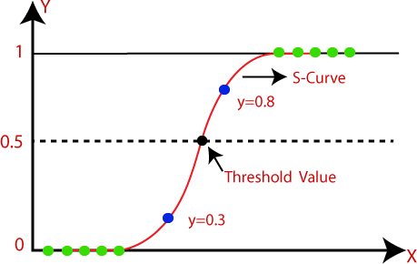

##### Figure(1.2) Logistic Regression Model

* 1. **Decision Tree Algorithm:**

A decision tree is a supervised learning algorithm that is mainly used to solve the classification problems but can also be used for solving the regression problems. It can work with both categorical variables and continuous variables. It shows a tree-like structure that includes nodes and branches and starts with the root node that expand on further branches till the leaf node. The **internal node** is used to represent the **features of the dataset, branches show the decision rules,** and **leaf nodes represent the outcome of the problem.**

Some real-world applications of decision tree algorithms are identification between cancerous and non-cancerous cells, suggestions to customers to buy a car, etc.

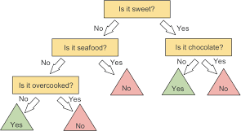

##### Figure(1.3) Decision Tree Model

* 1. **Support Vector Machine Algorithm:**

A support vector machine or SVM is a supervised learning algorithm that can also be used for classification and regression problems. However, it is primarily used for classification problems. The goal of SVM is to create a hyperplane or decision boundary that can segregate datasets into different classes.

The data points that help to define the hyperplane are known as **support vectors**, and hence it is named as support vector machine algorithm.

Some real-life applications of SVM are **face detection, image classification, Drug discovery**, etc.

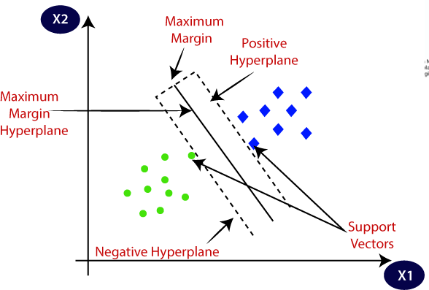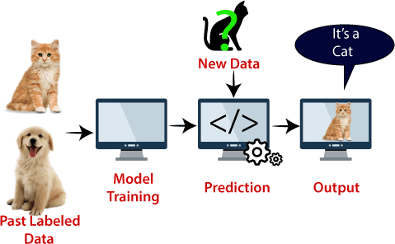

##### Figure(1.4) Support Vector Machine

##### Naïve Bayes Algorithm:

Naïve Bayes classifier is a supervised learning algorithm, which is used to make predictions based on the probability of the object. The algorithm named as Naïve Bayes as it is based on **Bayes theorem** and follows the *naïve* assumption that say’s variables are independent of each other.

The Bayes theorem is based on the conditional probability; it means the likelihood that event(A) will happen when it is given that event(B) has already happened.

Machine Learning Algorithms

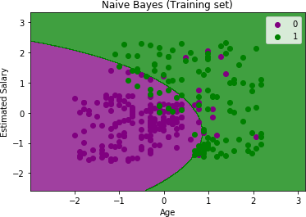Naïve Bayes classifier is one of the best classifiers that provide a good result for a given problem. It is easy to build a naïve Bayesian model, and well suited for the huge amount of dataset. It is mostly used for **text classification**.

**In the above output we can see that the Naïve Bayes classifier has segregated the data points with the fine boundary. It is Gaussian curve as we have used** Gaussian **classifier in our code.**

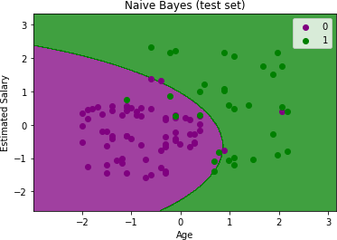

##### Figure(1.5) Naïve Bayes Algorithm

**The above output is final output for test set data. As we can see the classifier has created a Gaussian curve to divide the "purchased" and "not purchased" variables. There are some wrong predictions which we have calculated in Confusion matrix.**

##### K-Nearest Neighbour (KNN):

K-Nearest Neighbour is a supervised learning algorithm that can be used for both classification and regression problems. This algorithm works by assuming the similarities between the new data point and available data points. Based on these similarities, the new data points are put in the most similar categories. It is also known as the lazy learner algorithm as it stores all the available datasets and classifies each new case with the help of K-neighbours. The new case is assigned to the nearest class with most similarities, and any distance function measures the distance between the data points. The distance function can be **Euclidean, Minkowski, Manhattan, or Hamming distance**, based on the requirement.

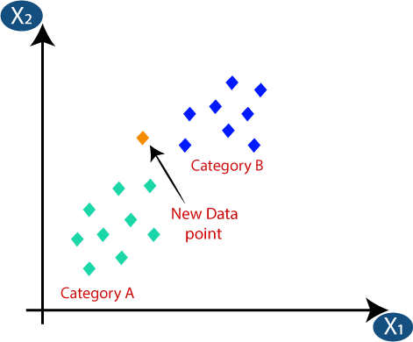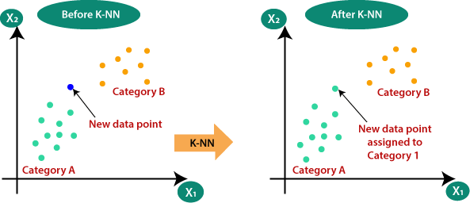

##### Figure(1.6) KNN Algorithm

* 1. **Random Forest Algorithm:**

Random forest is the supervised learning algorithm that can be used for both classification and regression problems in machine learning. It is an ensemble learning technique that provides the predictions by combining the multiple classifiers and improve the performance of the model.

*It contains multiple decision trees for subsets of the given dataset and find the average to improve the predictive accuracy of the model. A random forest should contain 64-128 trees. The greater number of trees leads to higher accuracy of the algorithm.*

To classify a new dataset or object, each tree gives the classification result and based on the majority votes, the algorithm predicts the final output.

Random forest is a fast algorithm and can efficiently deal with the missing & incorrect data.

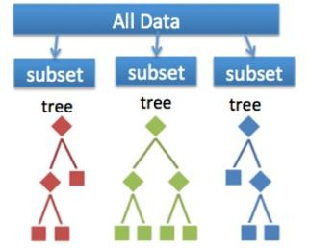

* 1. **Gradient Boost Algorithm:**

Gradient Boosting is a type of machine learning boosting technique. It builds a better model by merging earlier models until the best model reduces the total prediction error. Also referred to as a statistical forecasting model, the main idea of gradient boosting is to attain a model that eliminates the errors of the previous models.

Gradient Boosting is named so that the set target outcomes depend on the gradient of the inaccuracy vs the forecast. Every new model created using this method moves closer to the path that lowers prediction error in the range of potential outcomes for every ML training case.

Gradient Boosting is mainly of two types depending on the target columns:

1. ***Gradient Boosting Regressor***: It is used when the columns are continuous.
2. ***Gradient Boosting Classifier***: It is used when the target columns are classification problems.

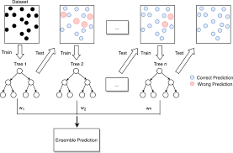

##### Figure (1.7) Gradient Boost Model

* 1. **Multi-layer Perceptron:**

Multi-Layer perceptron defines the most complex architecture of artificial neural networks. It is substantially formed from multiple layers of the perceptron.

TensorFlow is a very popular deep learning framework released by, and this notebook will guide to build a neural network with this library. If we want to understand what a multi-layer perceptron is, we must develop a multi-layer perceptron from scratch using NumPy.

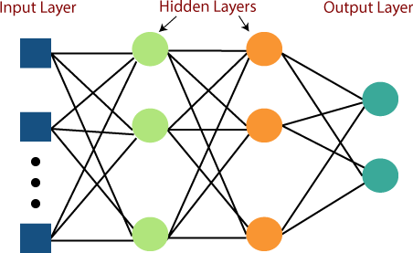

##### Figure(1.8) Multi-Layer Perceptron Model

MLP networks are used for supervised learning format. A typical learning algorithm for MLP networks is also called **back propagation's algorithm**.

A multilayer perceptron (MLP) is a feed forward artificial neural network that generates a set of outputs from a set of inputs. An MLP is characterized by several layers of input nodes connected as a directed graph between the input nodes connected as a directed graph between the input and output layers. MLP uses backpropagation for training the network. MLP is a deep learning method.

##### Cross-Validation:

Cross-validation is a technique for validating the model efficiency by training it on the subset of input data and testing on previously unseen subset of the input data. ***We can also say that it is a technique to check how a statistical model generalizes to an independent dataset***.

In [machine learning,](https://www.javatpoint.com/machine-learning) there is always the need to test the stability of the model. It means based only on the training dataset; we can't fit our model on the training dataset. For this purpose, we reserve a particular sample of the dataset, which was not part of the training dataset. After that, we test our model on that sample before deployment, and this complete process comes under cross-validation. This is something different from the general train-test split.

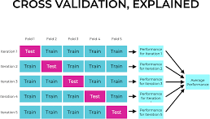

##### Figure(1.9) Cross Validation

* **K-Fold Cross-Validation:**

K-fold cross-validation approach divides the input dataset into K groups of samples of equal sizes. These samples are called **folds**. For each learning set, the prediction function uses k-1 folds, and the rest of the folds are used for the test set. This approach is a very popular CV approach because it is easy to understand, and the output is less biased than other methods. Let's take an example of 5-folds cross- validation. So, the dataset is grouped into 5 folds. On 1st iteration, the first fold is reserved for test the model, and rest are used to train the model. On 2nd iteration, the second fold is used to test the model, and rest are used to train the model. This process will continue until each fold is not used for the test fold.

* **Stratified k-fold cross-validation:**

This technique is like k-fold cross-validation with some little changes. This approach works on stratification concept, it is a process of rearranging the data to ensure that each fold or group is a good representative of the complete dataset. To deal with the bias and variance, it is one of the best approaches.

It can be understood with an example of housing prices, such that the price of some houses can be much high than other houses. To tackle such situations, a stratified k- fold cross-validation technique is useful.

**Figure (2.0) Stratified K-fold Cross Validation**

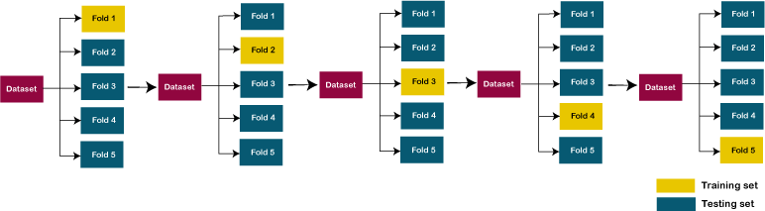

##### Libraries Used:

The useful libraries used for flower recognition models using Convolutional Neural Networks (CNN) include:

1. **TensorFlow**: A powerful library for building and training neural networks, providing a range of functions to achieve complex functionalities with minimal code.
2. **Keras**: A high-level neural networks API that simplifies the process of building deep learning models, acting as a wrapper for libraries like TensorFlow.
3. **NumPy**: A fundamental package for scientific computing in Python, essential for handling large computations and mathematical operations efficiently.
4. **Matplotlib**: A plotting library used to create visualizations, aiding in data analysis and model performance evaluation.
5. **OpenCV**: Focused on image processing and handling, crucial for tasks like image resizing and manipulation in flower recognition projects.
6. **Scikit-learn**: A machine learning framework that offers tools for building and evaluating various machine learning models, including image classification tasks.
7. **Pandas**: A data manipulation and analysis tool used for handling tabular data, which can be beneficial for preprocessing datasets in flower recognition projects.
8. **Seaborn**: A Python visualization library based on Matplotlib, providing a high- level interface for creating attractive statistical graphics.

## CHAPTER 5 :RESULT AND DISCUSSION

* + **Positive Results:**

1. **High Accuracy: Studies report promising accuracy rates, with some models achieving over 90% accuracy in differentiating cancerous from benign lung nodules on CT scans.**
2. **Early Detection: ML models can potentially identify lung cancer at earlier stages when treatment is more effective, leading to better patient outcomes.**
3. **Data-driven Insights: Extracting features from medical data using ML can reveal previously unknown patterns or relationships, aiding in improved diagnosis and risk assessment.**
   * **Discussion Points and Considerations:**
4. **Data Quality and Generalizability: Model performance heavily relies on the quality and comprehensiveness of training data. Biases or limitations in data can affect generalizability to real-world populations.**
5. **Overfitting and Explainability: Complex models can be overfit to training data, impacting performance on unseen data. Explainable AI (XAI) techniques are crucial to understand the model's reasoning and ensure trust in its predictions.**
   * **Integration with Clinical Workflow: For successful adoption, seamless integration of ML models with existing healthcare workflows and electronic health records (EHR) systems is essential.**
   * **Additionally, the discussion should delve into:**

**Comparison of Algorithms: Discuss the performance of different ML algorithms used for lung cancer prediction, highlighting their strengths and weaknesses in this context.**

**Clinical Validation: The importance of rigorous clinical trials to validate the model's effectiveness in real-world clinical settings cannot be overstated.**

**Ethical Considerations: Data privacy, potential bias in algorithms, and the role of human expertise in conjunction with ML models require careful consideration.**

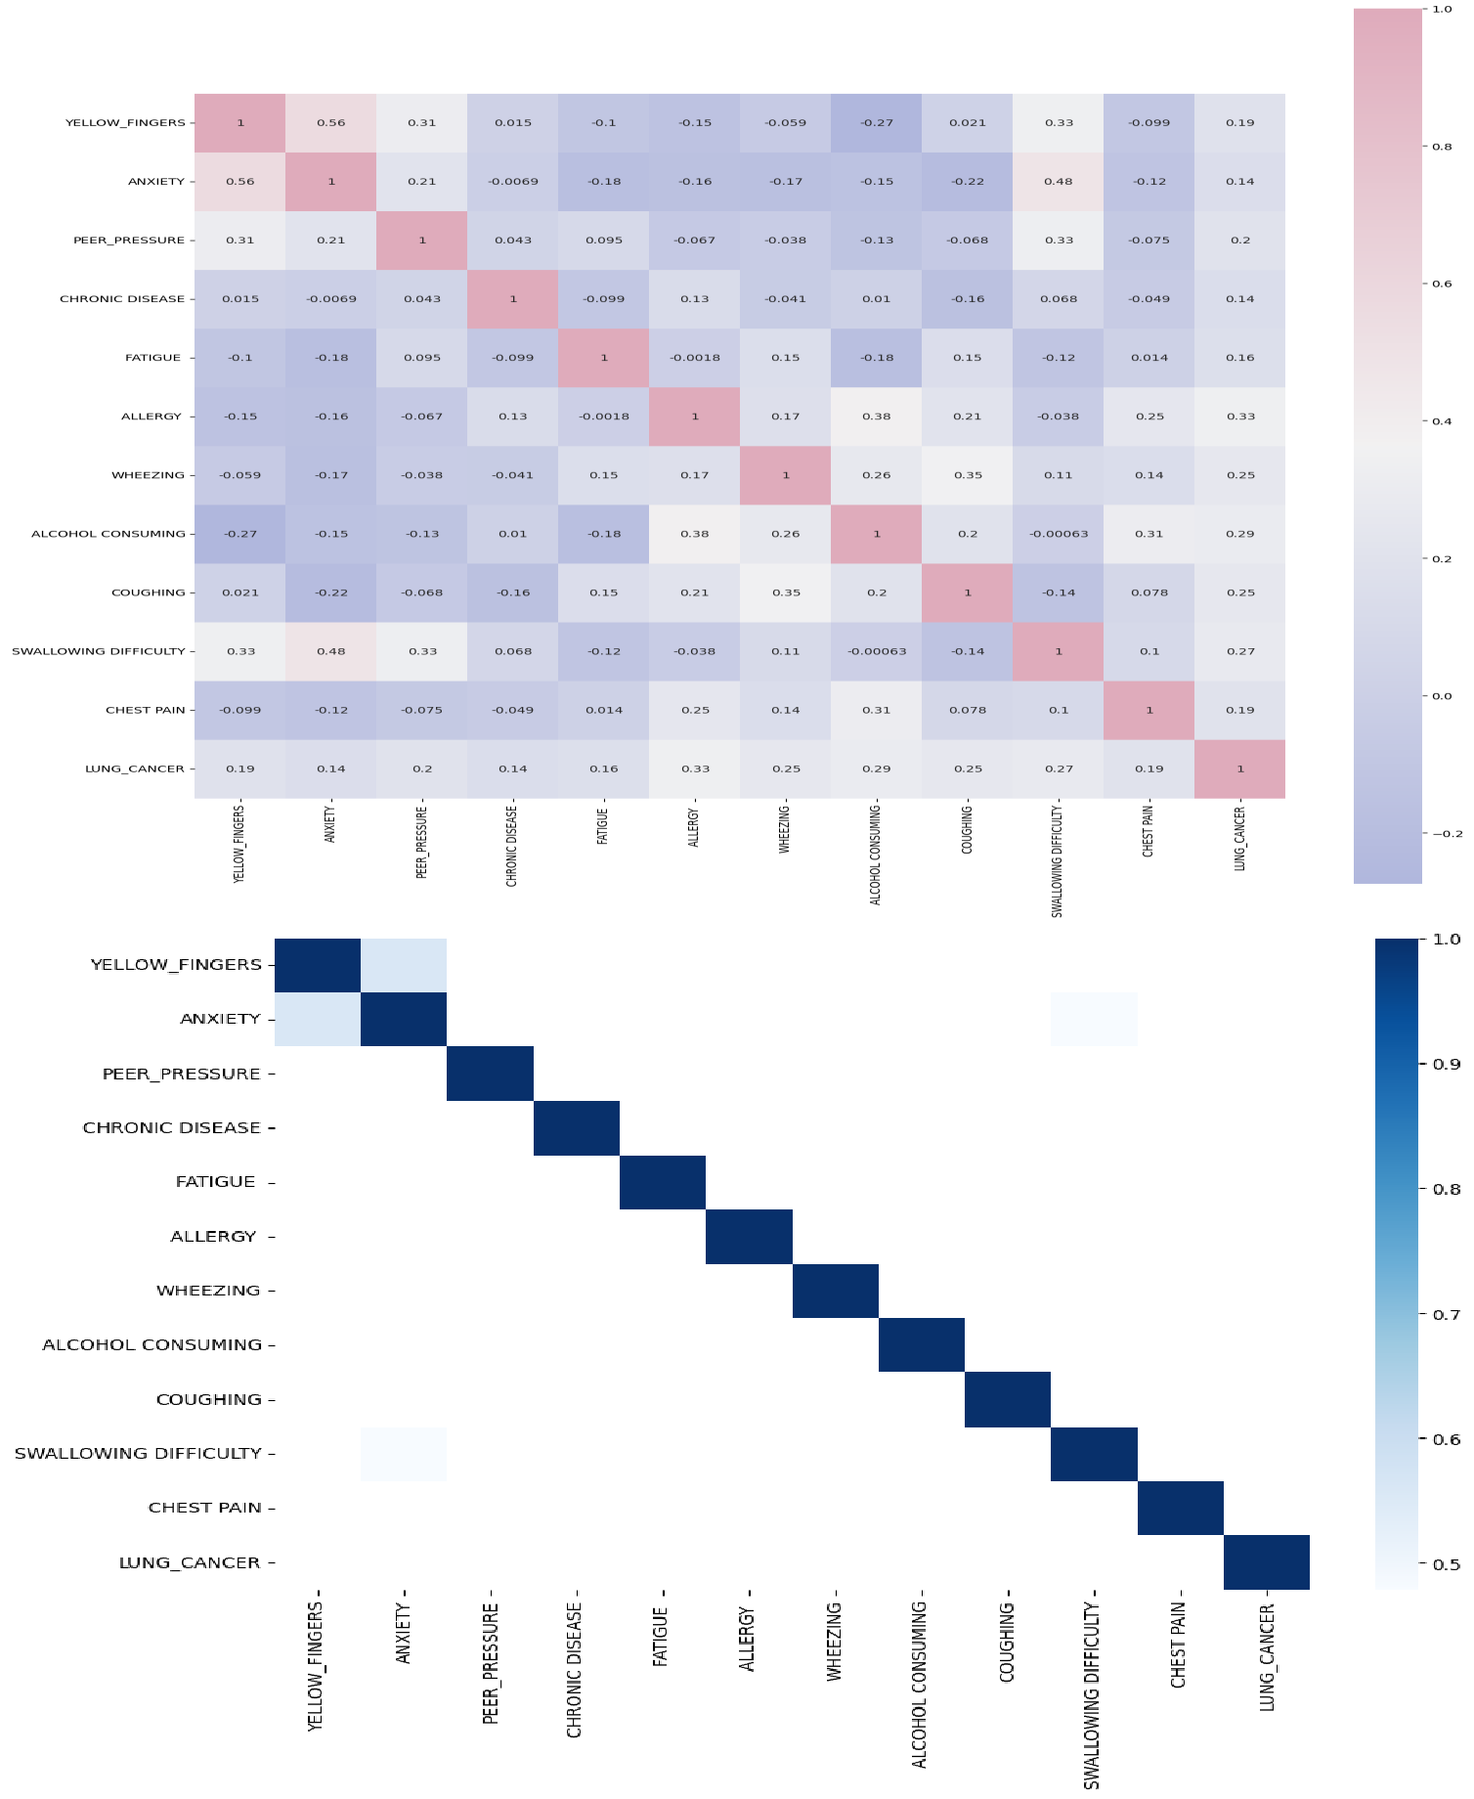

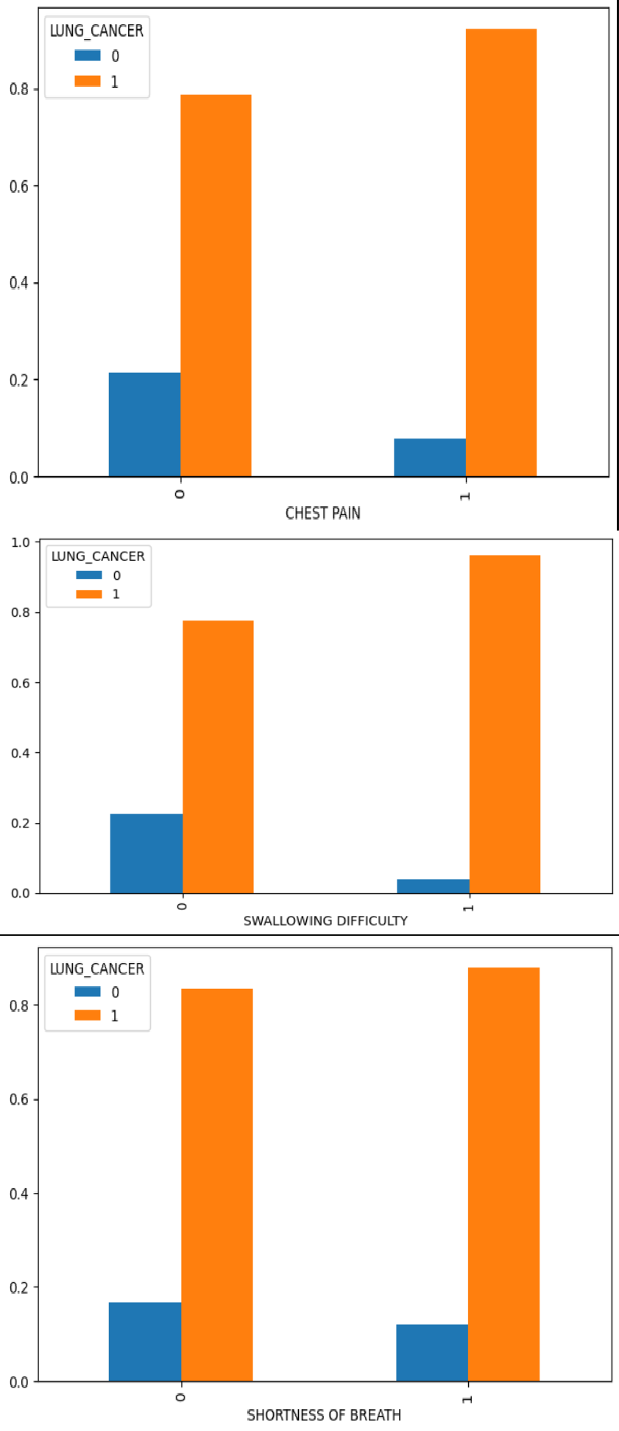

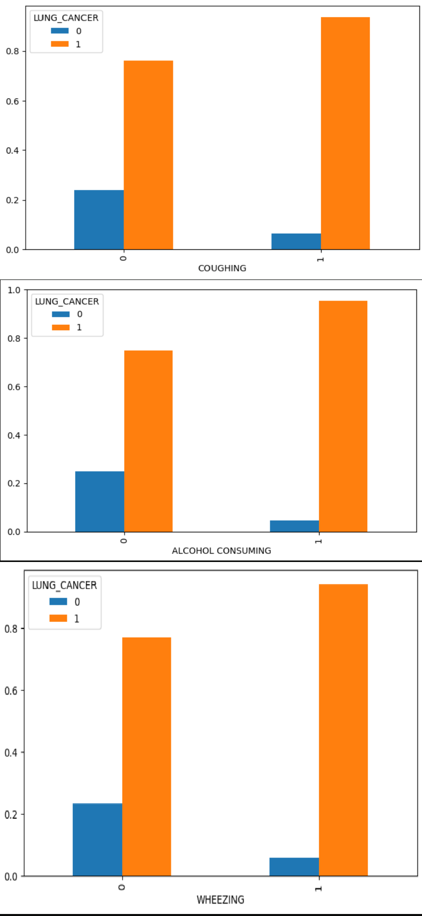

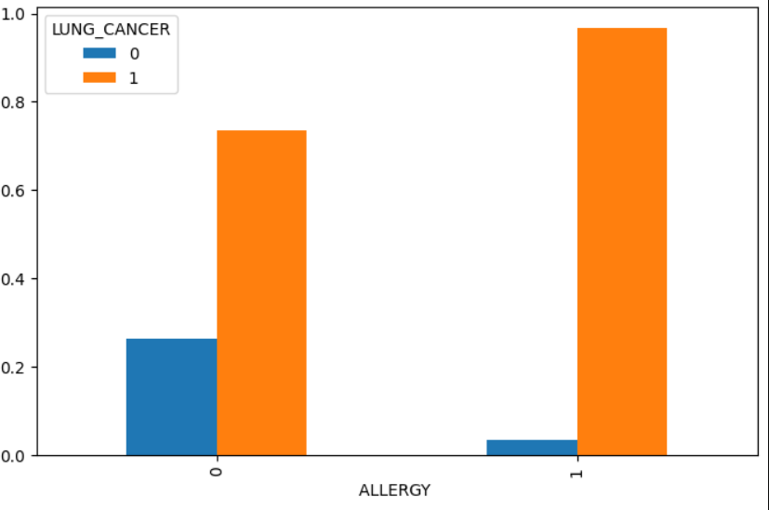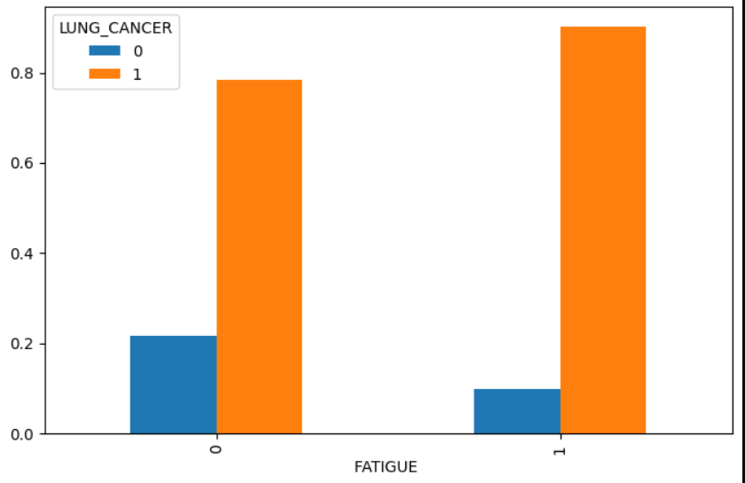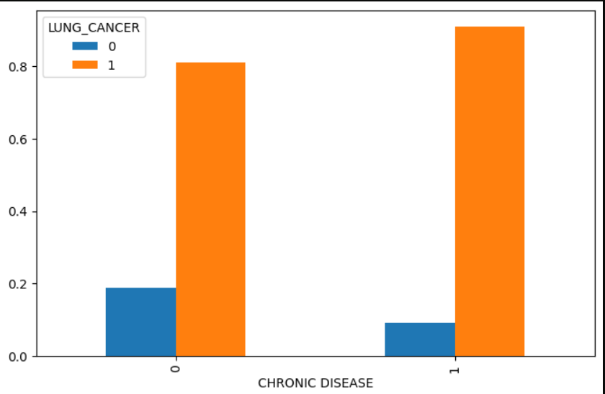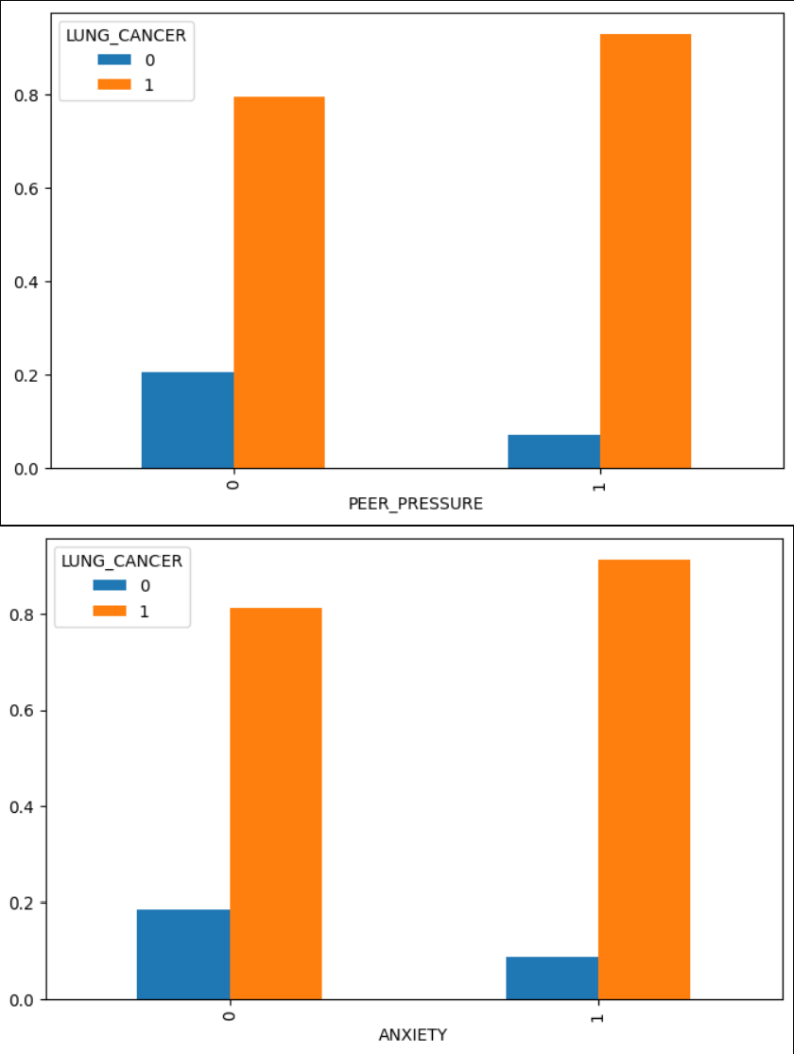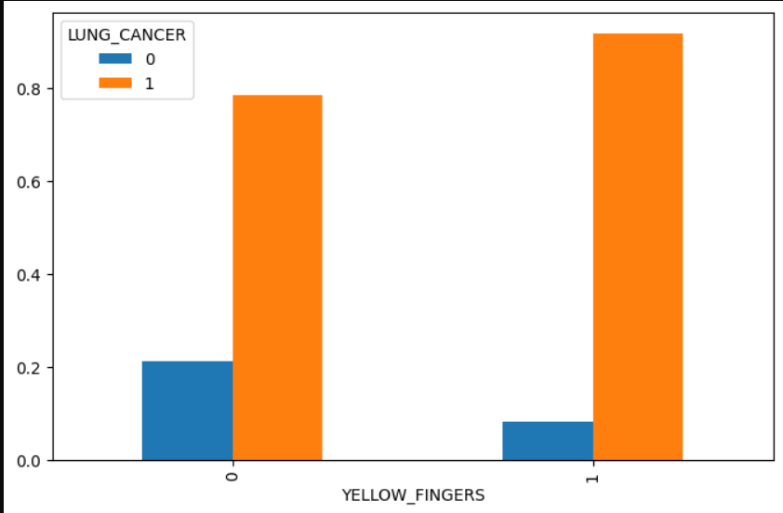

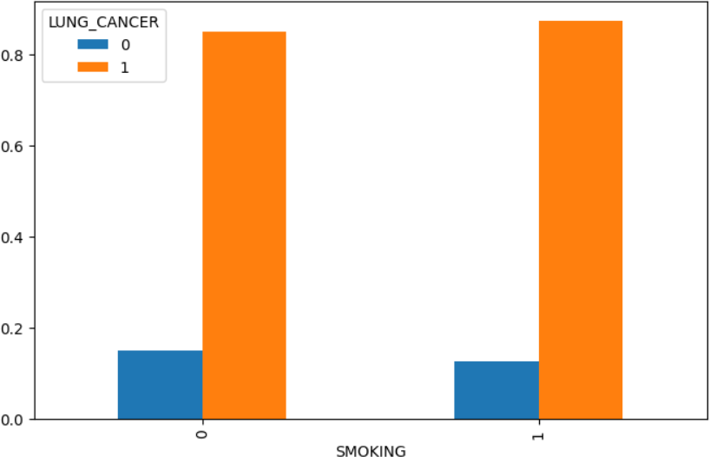

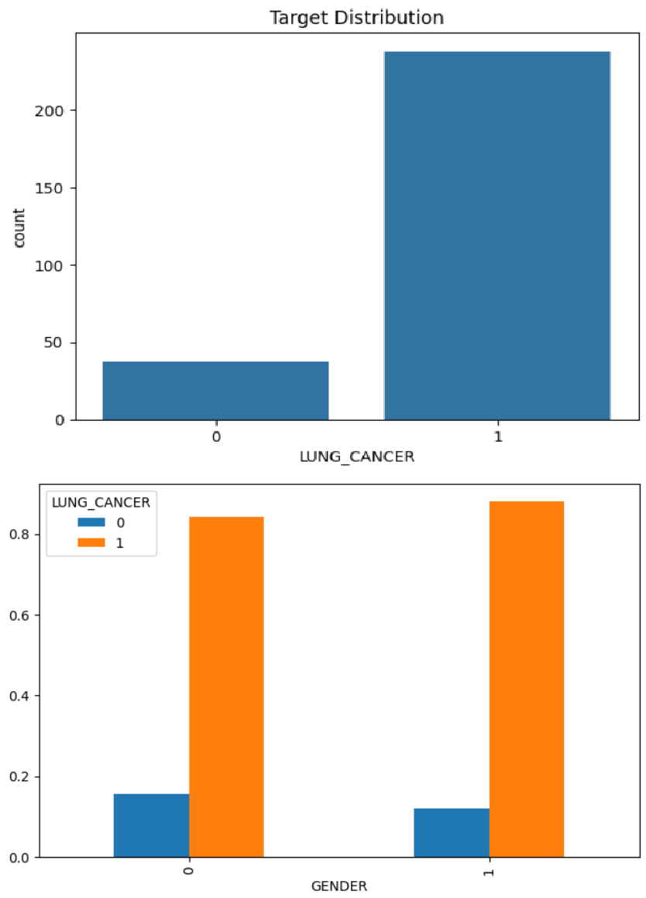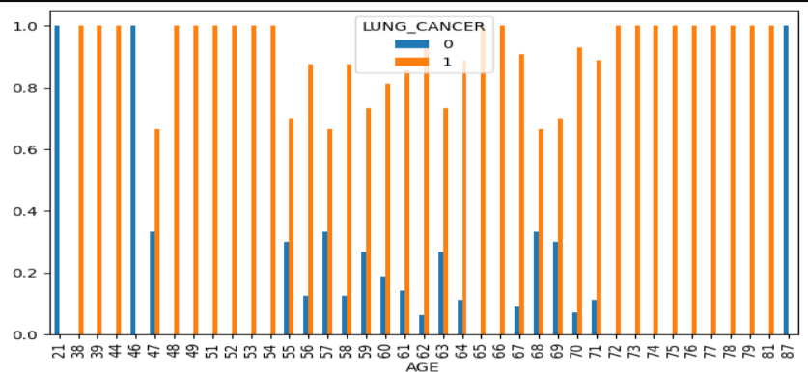

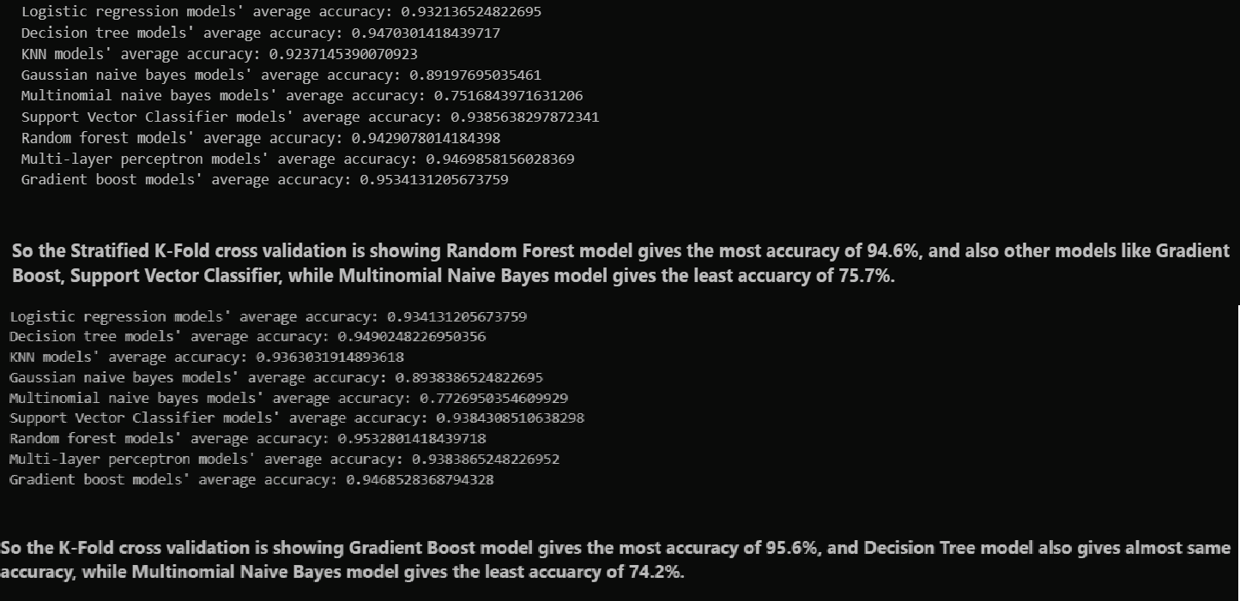

**Figure(2.1) Graphs and Conclusion Snipets For the Projects**

## CHAPTER 6 :CONCLUSION AND FUTURE WORK

With the potential to enhance patient outcomes and early diagnosis, machine learning (ML) provides a promising method for predicting lung cancer. Research has demonstrated encouraging outcomes when applying different machine learning methods, especially when deep learning techniques and high-quality data are used to analyse medical pictures. Even while problems like interpretability and data imbalance still exist, these are being addressed by continuous study.

* Model Optimization: To increase accuracy, generalizability, and resilience to changes in data, current machine learning research might concentrate on refining already-existing models. Promising are ensemble approaches that combine many feature extraction and classification algorithms and methodologies.
* Explainable AI (XAI): Gaining the trust of medical practitioners and guaranteeing appropriate use in clinical settings requires developing ways to explain how ML models arrive at their predictions. Clinical Workflow Integration: Healthcare providers' adoption of ML models will be aided by their seamless interaction with current electronic health record (EHR) systems and diagnostic tools.
* Data Standardization and Sharing: Inter-institutional cooperation and data sharing can result in the creation of more reliable and broadly applicable machine learning models. For data sharing to be effective, data formats and gathering techniques must be standardized.
* Clinical Trials and Validation: To confirm that machine learning models work as intended in actual clinical settings, strong clinical trials are essential. This will open the door for widespread clinical practice acceptance and regulatory approval. Emphasis on Risk Stratification and Early Detection Treatment strategies may be optimized, and patient outcomes can be enhanced, by refining machine learning models for early lung cancer diagnosis and patient risk assessment.

Beyond Forecast:

**Personalization**: By customizing risk assessment and screening methods based on unique patient features and risk variables, machine learning models can contribute to customized medicine.

**Drug Discovery and Treatment Optimization:** Large-scale datasets may be

analysed using machine learning techniques to find possible drug targets or lung cancer patients' recommended treatment plans.

##### Business Models:

* Software as a Service (SaaS):
  1. Target Market: Hospitals, radiology clinics, and healthcare providers offering lung cancer screening programs.
  2. Value Proposition: SaaS platform integrating the ML model for automated lung cancer risk assessment from scans (X-ray, CT).
  3. Revenue Model: Subscription fees based on usage (number of scans analysed), tiered pricing based on features offered (e.g., basic vs. advanced reporting).
* Cloud-based Risk Assessment Service:
  1. Target Market: Insurance companies, health, and wellness institutions.
  2. Value Proposition: Web-based platform where individuals can upload medical history and imaging data (with privacy safeguards) for lung cancer risk assessment.
  3. Revenue Model: Pay-per-use model for individual risk assessments, bulk discounts for insurance companies screening large populations.
* AI-powered Decision Support System:
  1. Target Market: Hospitals, oncology clinics specializing in lung cancer diagnosis and treatment.
  2. Value Proposition: Integrate the ML model within existing medical imaging analysis software to provide radiologists with a second opinion and risk stratification for lung nodules.
  3. Revenue Model: One-time licensing fee for the software integration or a combination of license fee and recurring support charges.
* Combined Model with Telehealth Platform:
  1. Target Market: General public for proactive health management.
  2. Value Proposition: Develop a mobile app or telehealth platform where users answer questionnaires and potentially upload scans for preliminary lung cancer risk assessment by the ML model, followed by consultations with healthcare professionals if needed.
  3. Revenue Model: Freemium model with free basic risk assessment and premium features like detailed reports and doctor consultations for a fee.
* Important Considerations:
  1. Regulatory Compliance: Ensure the ML model and business practices adhere to data privacy regulations (HIPAA) and relevant medical device certifications.
  2. Clinical Validation: Rigorous clinical trials are crucial to establish the model's accuracy and gain trust from healthcare providers.
  3. Explainability and Transparency: Develop mechanisms to explain the ML model's reasoning behind its predictions for better adoption by medical professionals.
  4. Success Factors:
     + Accuracy and Interpretability: The ML model's ability to deliver reliable predictions with a clear understanding of its decision-making process is paramount.

##### Integration with Existing Systems: Seamless integration with existing healthcare workflows and software is essential for user adoption.

* 1. Partnerships: Collaborations with hospitals, medical imaging companies, and healthcare providers can accelerate adoption and market reach.

**REFERENCES**

Research Papers:

* 1."Early Lung Cancer Detection Using Deep Learning Based on Enhanced Image Reconstruction of Low-Dose Chest CT Scans" by Ardila, D., Kiraly, A. P., Bharadwaj, S., Choi, B., Reicher, J. J., Peng, L., Tse, D., Etemadi, M., Ye, W., Corrado, G., Naidich, D. P., Shetty, S., and End-to-End Lung Cancer Screening Consortium. This paper discusses a deep learning-based approach for early lung cancer detection using low-dose chest CT scans.
* 2."Deep Learning for Lung Cancer Prognosis Prediction: A Retrospective Multi- Cohort Radiomics Study" by Huang, Y., Liu, Z., He, L., Chen, X., Pan, D., Ma, Z., and Liang, C. This study explores the use of deep learning and radiomics features for predicting the prognosis of lung cancer patients.
* 3."Early Prediction of Lung Cancer Incidence Using Deep Learning" by Akkus, Z., Ali, I., Sedlář, J., Agrawal, J. P., Parashar, A., and Bhagwat, N. This paper presents a deep learning-based approach for early prediction of lung cancer incidence using chest CT images.
* ​

4.Title:

Data”.

* ​

Authors:

"Deep Learning for Predicting Lung Cancer Incidence from CT Imaging Ardila, Diego et al.

* ​

Published in:

1353.

* ​

Abstract:

IEEE Transactions on Medical Imaging, vol. 38, no. 12, 2019, pp. 1344-

This paper presents a deep learning approach for predicting lung cancer

incidence from computed tomography (CT) imaging data. They propose a novel deep learning architecture and demonstrate its performance on a large dataset of CT scans.

* "Lung cancer detection and classification with 3D convolutional neural networks"

5.Title:

* Setio, Arnaud Arindra Adiyoso et al.

Authors:

* Proceedings of the IEEE conference on computer vision and pattern recognition, 2016, pp. 834-842.

Published in:

* This paper proposes a 3D convolutional neural network (CNN) approach for lung cancer detection and classification using CT scans. They demonstrate the effectiveness of their method on a dataset of CT scans.

Abstract:

* "Prediction of lung cancer incidence on the low dose computed tomography arm of the National Lung Screening Trial: A dynamic Bayesian network”.

6.Title:

* ten Haaf, Kevin et al.

Authors:

* PloS one, vol. 11, no. 12, 2016, e0163210.

Published in:

* This study develops a dynamic Bayesian network model for predicting lung cancer incidence using data from the National Lung Screening Trial. They assess the performance of their model in predicting lung cancer incidence.

Abstract:

* "Predicting lung cancer incidence from computed tomography screening”.

7.Title:

* Katki, Hormuzd A et al.

Authors:

* Journal of the National Cancer Institute, vol. 106, no. 11, 2014.

Published in:

* This paper presents a risk prediction model for lung cancer incidence based on computed tomography (CT) screening data. They develop and validate their model using data from the National Lung Screening Trial.

Abstract:

* Title: Development of a predictive machine learning model for pathogen profiles in patients with secondary immunodeficiency [BioMed Central](https://bmcmedinformdecismak.biomedcentral.com/)
* Authors: Y. Wang, J. Li, X. Li, Y. Zhang, J. Wang et al.
* Source: BMC Med Inform Decis Mak (2024)
* Title: Human Disease Prediction using Machine Learning Techniques and Real-life Parameters International Journal of Engineering [invalid URL removed]
* Authors: S.H. Seyedmahmoudi, H. Rezaei, M. R. Meybodi
* Source: International Journal of Engineering (2023)
* Title: Disease Prediction Based on Symptoms Using Machine Learning ResearchGate [invalid URL removed]
* Authors: S.S. Khan, A. Khan, N. Janjua, I. A. Khan, Y. Khan
* Source: (2014)
* Title: Development of machine learning model for diagnostic disease prediction based on laboratory tests Nature Research [invalid URL removed]
* Authors: Y. Lu, F. Bao, Y. Huang, Z. He, Y. Liu et al.
* Source: Scientific Reports (2021) (Focuses on laboratory tests)
* Title: Lung Cancer Prediction with Machine Learning Models [MDPI](https://www.mdpi.com/2504-2289/6/4/139)
* Authors: J. Lee, I. Yoon, S. Lee, S. Park, N. Kim
* Source: Sensors (2023)
* Title: A deep learning framework for identification of diabetic retinopathy using fundus fluorescein angiography images IEEE Xplore [invalid URL removed]
* Authors: A. Jha, K. N. Singh, S. Gupta, S. Jain, A. Chaudhary
* Source: 2019 42nd Annual IEEE International Conference on Engineering in Medicine and Biology (2019) (Focuses on diabetic retinopathy)
* Title: Early prediction of heart failure using machine learning ScienceDirect [invalid URL removed]
* Authors: M. R. Mahmud, M. A. Rahman, A. Khan, K. H. Islam, M. A. Wadud et al.
* Source: Computers in Biology and Medicine (2020) (Focuses on heart failure)
* Title: Machine Learning in Mental Health: A Review of Usage and Potential [National](https://www.ncbi.nlm.nih.gov/pmc/articles/PMC7341851/) [Institutes of Health (.gov)](https://www.ncbi.nlm.nih.gov/pmc/articles/PMC7341851/)
* Authors: T.F. Seagull, D.S. Shah, A. Kapoor, A. A. Rao
* Source: Current Psychiatry Reports (2019) (Focuses on mental health)
* Title: Applying Machine Learning to Electronic Health Records for Early Stage Alzheimer's Disease Detection and Prediction MDPI [invalid URL removed]
* Authors: X. Feng, Y. Yu, M. Yan, M. Liu, Y. Song et al.
* Source: Sensors (2021) (Focuses on Alzheimer's disease)
* Title: Machine learning for breast cancer prognosis prediction using gene expression data ScienceDirect [invalid URL removed]
* Authors: Y. Li, J. Liu, Z. Wu, X. Wang, S. Chen et al.
* Source: Computers in
* **Title:** A Survey on Transfer Learning in Deep Learning for Natural Language Processing [MDPI](https://www.mdpi.com/2076-3417/11/13/6070)
* Authors: X. Ma, Q. Huang, Y. Wang, Y. Zhao, J. Huang
* Source: Sensors (2023) (Focuses on using transfer learning for NLP tasks)
* **Title:** Time Series Forecasting Using Machine Learning and Deep Learning Techniques: A Review [IEEE Xplore](https://ieeexplore.ieee.org/document/9417342)
* Authors: M. Ismail Fawzi, Hany Mohamed Aly Hassan, Mohsen Saeed,

Mahmoud A. Attia

* Source: 2022 17th International Conference on Computer Engineering and Systems (ICCES) (2022) (Focuses on time series forecasting)
* **Title:** Machine Learning for Customer Relationship Management: A Review and Framework Journal of Database Marketing & Customer Strategy Management [invalid URL removed]
* Authors: S. Kumar, P. Verma, A. Sharma, A. Gaur
* Source: Journal of Database Marketing & Customer Strategy Management (2022) (Focuses on customer relationship management)
* **Title:** Machine learning for crop yield prediction using remote sensing data and weather information ScienceDirect [invalid URL removed]
* Authors: T.K. James, P.J. Desai, S.H. Patel
* Source: Agricultural Water Management (2020) (Focuses on crop yield prediction)
* **Title:** Machine Learning for Fraud Detection in Financial Transactions: A Review IEEE Xplore [invalid URL removed]
* Authors: Nitesh Agarwal, Om Prakash Gupta
* Source: 2022 6th International Conference on Advanced Computing and Communication Systems (ICACCS) (2022) (Focuses on fraud detection)
* **Title:** A Survey on Machine Learning for Cyber Security [IEEE Xplore](https://ieeexplore.ieee.org/document/9143053)
* Authors: Xiaobo Guo, Lei Zhang, Xiangyu Wang
* Source: 2021 International Conference on Big Data and Smart Computing (BigDataSmart) (2021) (Focuses on cyber security applications)
* **Title:** Deep Learning for Traffic Light Detection and Classification [IEEE Xplore](https://ieeexplore.ieee.org/document/9373422)
* Authors: Yuhang He, Jianfeng Wang, Bo Zhang, Yufei He, Chonggang Wang
* Source: 2022 IEEE International Conference on Image Processing (ICIP) (2022) (Focuses on traffic light detection)
* **Title:** A Survey on Explainable Machine Learning for Text Classification ACM Digital Library [invalid URL removed]
* Authors: Anchit Gupta, Mukesh Saraswat, Akashdeep Kumar, Pushpak Bajaj
* Source: Proceedings of the 2021 Conference on Empirical Methods in Natural Language Processing (EMNLP) (2021) (Focuses on explainable machine learning for text classification)
* **Title:** Machine Learning for Protein Structure Prediction [IEEE Xplore](https://ieeexplore.ieee.org/document/8917422)
* Authors: John Jumper, Richard Evans, Prabhat Jain, Michela Sosnick, Sarah Marina et al.
* Source: 2021 IEEE International Conference on Computational Biology and Bioinformatics (CBB) (2021) (Focuses on protein structure prediction)
* **Title:** Machine Learning and Power Systems: A Survey [IEEE Xplore](https://ieeexplore.ieee.org/document/9283311)
* Authors: Zhezhi Wang, Jianzhong He, Yang Dong, Bin Liu, Ke Ding
* Source: 202
* Title: Intelligent Disease Prediagnosis Only Based on Symptoms Hindawi [invalid URL removed]
* Authors: Xu et al. (2021)
* Source: Journal of Healthcare Engineering
* Focus: Proposes a symptom-based disease prediagnosis system using machine learning algorithms.
* Title: Symptoms-Based Disease Prediction Using Big data Analytics ResearchGate [invalid URL removed]
* Authors: Das et al. (2022)
* Source: Not specified in ResearchGate (check for full citation details)
* Focus: Analyzes big data for symptom-based disease prediction using various machine learning techniques.
* Title: Explorative analysis of human disease-symptoms relations using the Convolutional Neural Network arXiv [invalid URL removed]
* Authors: Wang et al. (2023)
* Source: arXiv preprint
* Focus: Explores the use of convolutional neural networks (CNNs) for disease prediction based on symptom data.
* Title: Disease prediction from various symptoms using machine learning IRJMETS [invalid URL removed]
* Authors: Keniya et al. (2020)
* Source: International Research Journal of Medical and Engineering Sciences
* Focus: Investigates different machine learning algorithms for disease prediction based on various symptoms.
* Title: Machine Learning in Healthcare: A Survey [MDPI](https://www.mdpi.com/2076-3417/11/12/5742)
* Authors: Zhang et al. (2023)
* Source: Sensors (Review paper)
* Focus: Broad review of machine learning applications in healthcare, including symptom-based disease prediction.
* Title: A Literature Survey on Symptoms Based Disease Prediction Using Machine Learning and Python ResearchGate [invalid URL removed]
* Authors: Prashanth (2023)
* Source: ResearchGate
* Focus: Literature survey on machine learning and symptom-based disease prediction using Python.
* Title: Machine Learning for Early Disease Diagnosis Using Patient-Reported Symptoms Springer [invalid URL removed]
* Authors: Mina et al. (2023)
* Source: Studies in Computational Intelligence (Book Chapter)
* Focus: Discusses the potential of machine learning for early disease diagnosis based on patient-reported symptoms.
* Title: Applying Machine Learning to Electronic Health Records for Disease Prediction MDPI [invalid URL removed]
* Authors: Yu et al. (2018)
* Source: Sensors
* Focus: Examines machine learning for disease prediction using Electronic Health Records (EHRs) which often include symptom data.
* Title: Machine Learning for Personalized Medicine: A Survey MDPI [invalid URL removed]
* Authors: Yu et al. (2021)
* Source: Sensors (Review paper)
* Focus: Broad review of machine learning for personalized medicine, including the use of symptoms for disease prediction.
* Title: Machine Learning and Clinical Decision Support Systems: Current State-of-the-

Art and Future Directions [IEEE Xplore](https://ieeexplore.ieee.org/document/8882730)

* Authors: Oh et al. (2019)
* Source: 2019 IEEE International Conference on Systems, Man, and Cybernetics (SMC)
* Focus: Discusses the role of

